SampleCMS

Management Information System

Manual

2018/03/24, Lozen Lin

Table of Contents

1. Intorduction 4

2. System Management 5

2.1. Account management 5

2.1.1. Usage Scenario: View designated account data 5

2.1.2. Usage Scenario: Change name, password, email of account basic information 7

2.1.3. Usage Scenario: Change validation date, department, role of account advanced information 8

2.1.4. Usage Scenario: Suspend account 9

2.1.5. Usage Scenario: Add account 10

2.1.6. Usage Scenario: Delete account 12

2.2. Role & Privilege management 13

2.2.1. Usage Scenario: View designated role data 13

2.2.2. Usage Scenario: Change name, sort number of role basic information 15

2.2.3. Usage Scenario: Adjust privileges of role 15

2.2.4. Usage Scenario: Add role and copy privileges 18

2.2.5. Usage Scenario: Delete role 19

2.3. Department management 19

2.3.1. Usage Scenario: View designated department data 19

2.3.2. Usage Scenario: Change name, sort number of department basic information 21

2.3.3. Usage Scenario: Add department 21

2.3.4. Usage Scenario: Delete department 22

2.4. Operating log 23

2.4.1. Usage Scenario: View operating log 23

3. Site Architecture Management 25

3.1. Usage Scenario: View designated page data 25

3.2. Usage Scenario: Add sub-page data at designated page (unit) 29

3.3. Usage Scenario: use angular-filemanager to manage files 33

3.4. Usage Scenario: Add attachment of designated page 34

3.5. Usage Scenario: Add picture of designated page 36

3.6. Usage Scenario: Add picture in context of page 38

3.7. Usage Scenario: Add Youtube video of designated page 41

3.8. Usage Scenario: Change layout of page 43

3.9. Usage Scenario: Create a page that will transfer to sub-page automatically 44

3.10. Usage Scenario: Create a list page 45

3.11. Usage Scenario: Make the hyperlink of designated page appear in the unit area 46

3.12. Usage Scenario: Make the hyperlink of designated page appear in the sitemap 47

3.13. Usage Scenario: Change the designated page to become a hyperlink to open an external web page 48

3.14. Usage Scenario: Make designated page using custom web program to render front-stage page 49

3.15. Usage Scenario: Make designated page using layout control to render front-stage page 51

3.16. Usage Scenario: Make designated page using easy-to-remember URL alias 53

3.17. Usage Scenario: Immediately update search sources 54

4. Operation Management 55

4.1. Usage Scenario: View designated operation data 55

4.2. Usage Scenario: Change subject, icon, to hide or not of operation basic information 57

4.3. Usage Scenario: Add operation data as a functional group 58

4.4. Usage Scenario: Add operation data that using specific feature 59

4.5. Usage Scenario: Add operation data with embedded web page 60

4.6. Usage Scenario: Add operation data with page of [Site Architecture Mgmt.] and set privileges 62

# Intorduction

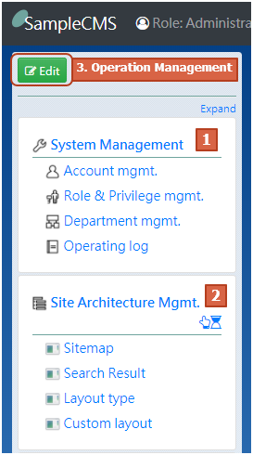[SampleCMS Management Information System] is a Content Management System (CMS) that manage the architecture and content of pages of website [SampleCMS Demo].

[SampleCMS Management Information System] provides three major functions.

1. System Management
2. Site Architecture Management
3. Operation Management

(as the picture shows)

System Management provides account and permission related management functions.

Site Architecture Management is the most important function of this system. It provides the ability to organize all page hierarchies and manage the presentation, content, and attachments of each page.

Operation Management is for administrators. It provides the ability to organize operation items hierarchy and URLs of System Menu on left side.

# System Management

## Account management

### Usage Scenario: View designated account data

After logging in to the system, select [System Management / Account mgmt.] from System Menu.

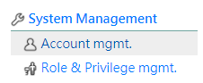

or select [Account settings] from the Login Information Menu in the upper right corner of the screen.

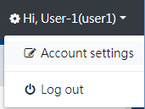

You can see the account list of this system (as shown below).

Most users can only see personal account.

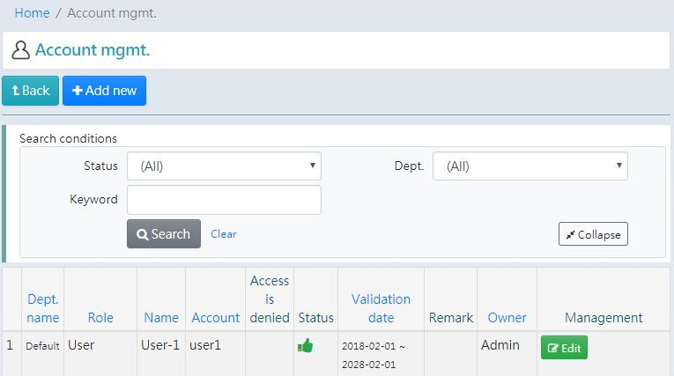

Administrators or other authorized users can see other people’s account (as shown below).

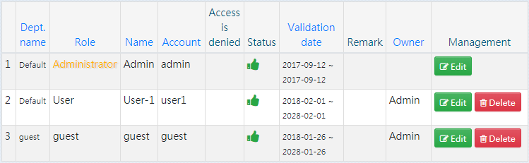

If there are too many accounts, you can use search conditions or press on the field name to change data order to help find accounts.

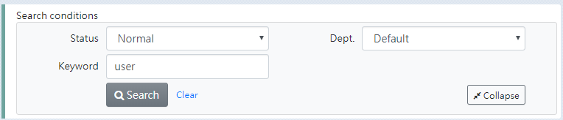

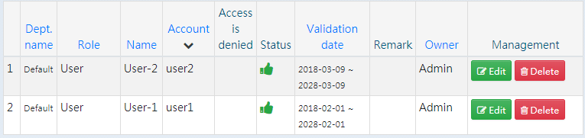

There are some fields of account data can be seen in the account list. Press the Edit button  to open account data will get more information (as shown below).

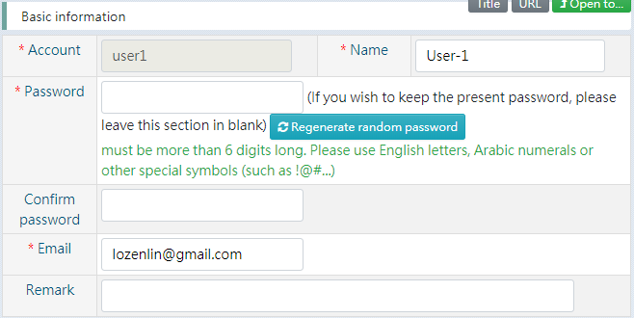

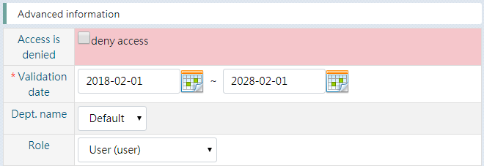

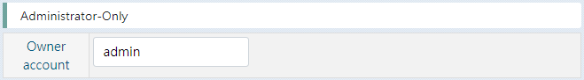

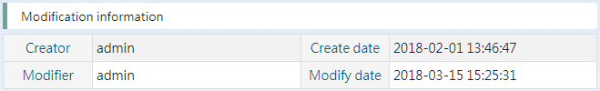

### Usage Scenario: Change name, password, email of account basic information

After finding your personal account or designated account according to the [Usage Scenario: View designated account data], press the Edit button  to open account data (as shown below).



Modify the text of fields and press the Save button  to update data.

* When changing password, please fill in [Password] and [Confirm password] fields.

* You can use the Regenerate random password button to generate a set of ten word random value (as shown below).

Filling in the [Confirm password] field in this way is not necessary.

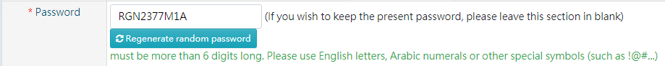

### Usage Scenario: Change validation date, department, role of account advanced information

After finding your personal account or designated account according to the [Usage Scenario: View designated account data], press the Edit button to open account data. The advanced information is only allowed to be modified by owner and administrator. Usually, user can only view the advanced information when viewing personal account (as shown below).

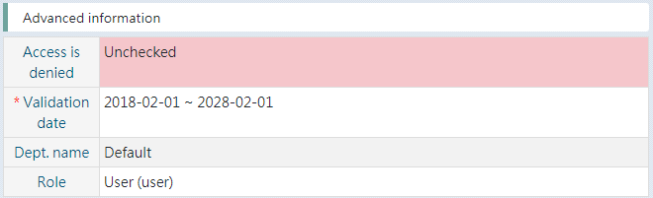

If you are the owner of opened account data, you can modify fields of advanced information section (as shown below).

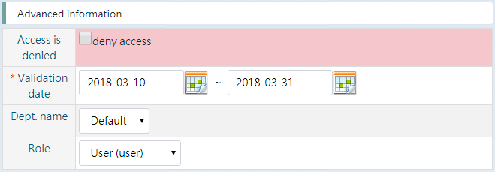

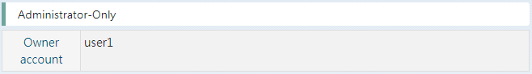

Modify the text of fields and press the Save button  to update data.

* Regarding the field [Role], only the administrator is allowed to select the value “Administrator (admin)”.

### Usage Scenario: Suspend account

After finding your personal account or designated account according to the [Usage Scenario: View designated account data], press the Edit button to open account data. Suspended setting is placed in the advanced information section. Only administrator or the owner of the account is allowed to modify setting.

There are two ways to disable an account so that it can no longer login to the system.

1. Check “deny access” and save the data.

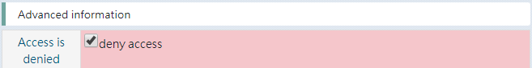

After changing the setting, denied icon  will be appeared in the field [Access is denied] of data of account list. Denied or expired icon  will be appeared in the field [Status] of data of account list.

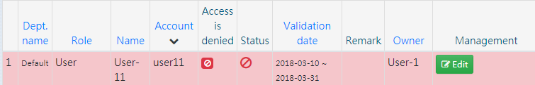

1. Change the end date of field [Validation data] to yesterday. For example, today is 2018-03-15, set the end date to 2018-03-14.

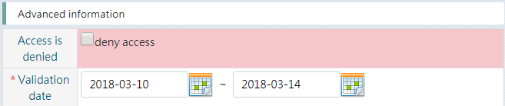

After changing the setting, Denied or expired icon  will be appeared in the field [Status] of data of account list.

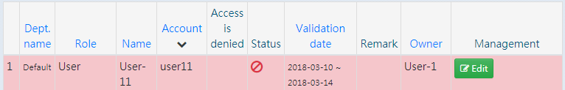

### Usage Scenario: Add account

After finding account list according to the [Usage Scenario: View designated account data]. If you are granted the right to add an account, you can find the Add new button  below the unit subject [Account mgmt.].

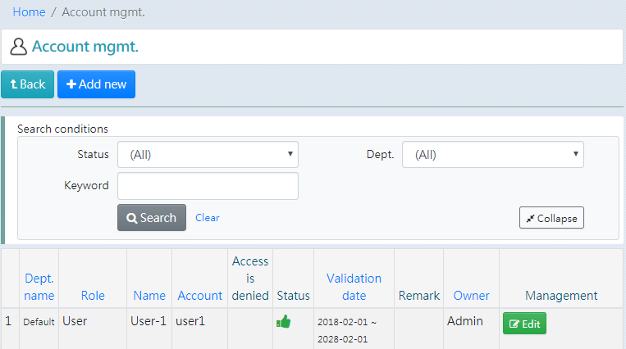

Press the Add new button to open blank form and fill in the data of new account.

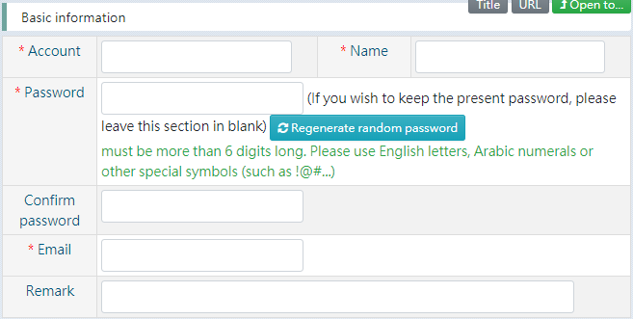

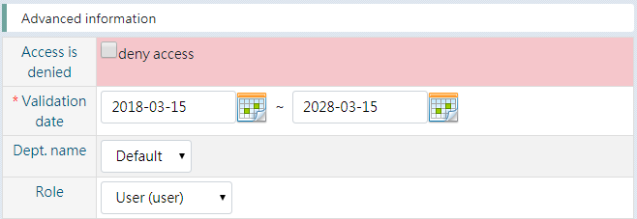

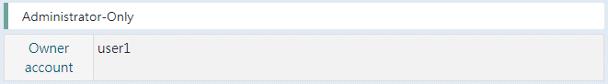

Press the Save button  to complete the data creation.

* The field [Owner account] will automatically fill in your account by system. Only administrator can modify this field (as shown below).

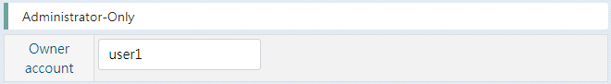

* To specify that the account is not yet loginable, wait until the specified date to start logging in, please change the start date of the field [Validation date]. For example, today is 2018-03-15, set the start date to 2018-03-16, then designated account is allowed to log in to the system at 2018-03-16 00:00:00.

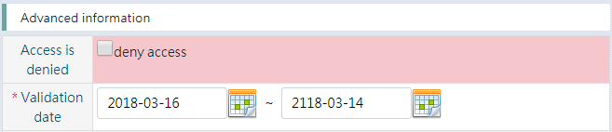

After changing the setting, the On schedule icon  will be appeared in the field [Status] of data of account list.

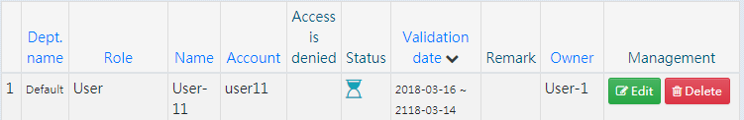

### Usage Scenario: Delete account

After finding account list according to the [Usage Scenario: View designated account data] (as shown below). If you are granted the right to delete an account, you can find the Delete button  in the field [Management] of data of account list.



Press the Delete button and a confirmation message will appear (as shown below). Press OK to delete account data.

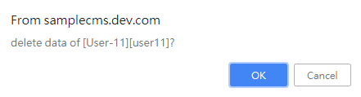

## Role & Privilege management

### Usage Scenario: View designated role data

After logging in to the system, select [System Management / Role & Privilege mgmt.] from System Menu.

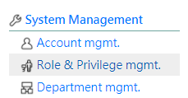

You can see the role list of this system (as shown below). If you are authorized, you can see more roles.

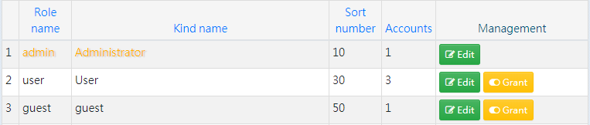

If there are too many roles, you can use search conditions or press on the field name to change data order to help find accounts (as shown below).

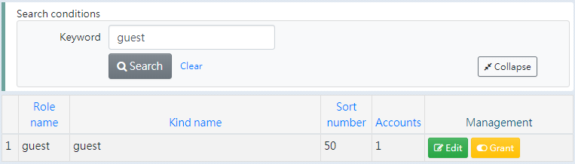

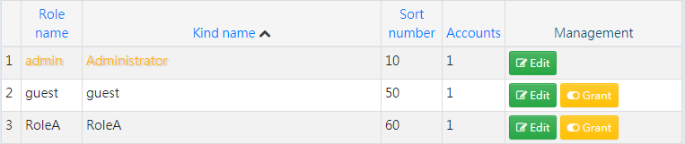

There are some fields of role data can be seen in the role list. Press the Edit button  to open role data will get more information (as shown below).

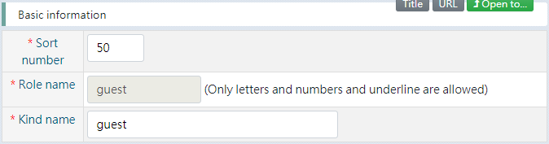

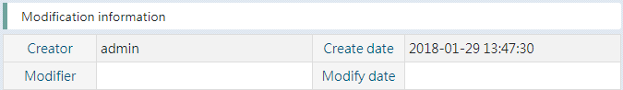

To view detailed privilege settings, press the Grant button  to open authorization form (as shown below).

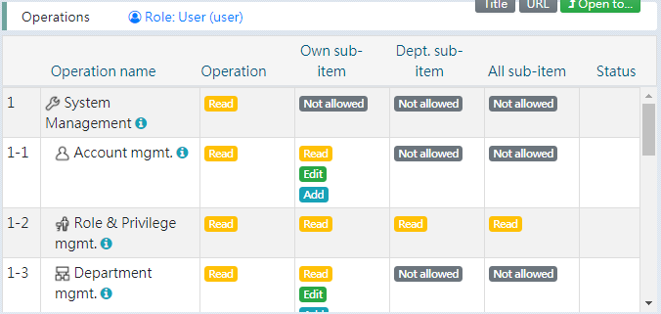

### Usage Scenario: Change name, sort number of role basic information

After finding designated role according to the [Usage Scenario: View designated role data], press the Edit button  to open role data (as shown below).

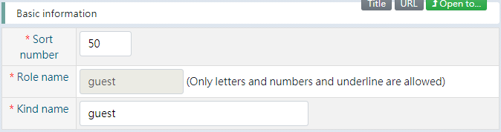

Modify the text of fields and press the Save button  to update data.

### Usage Scenario: Adjust privileges of role

The definition of the scope of authority is divided into two types, on being “behavior” and the other being “ownership”.

Behavior

The definition of behavior includes “Read”, “Edit”, “Delete”, and “Add”. “Read” is the most basic behavior. You must authorize “Read” before you can upgrade the authorization to “Modify”, then “Delete” and “Add”.

When changing the authorization of a role, if you select “Edit”, then “Read” is also authorized for the role. If you select “Read” from the “Delete” you originally selected. The system will automatically cancel the “Delete”, “Edit” and “Add” authorizations.

Ownership

The definition of ownership is built on the relationship between the authorized role and creator of the “Sub-items of operation” and includes “Own sub-item”, “Dept. sub-item”, and “All sub-item”. The system only allows the authorized role to use the “Sub-item of operation” that it is authorized. “Own sub-item” is the most basic ownership. You must authorize “Own sub-item” before you can upgrade the authorization to “Dept. sub-item”, then “All sub-item”.

When changing the authorization of a role, if you select “Dept. sub-item”, then “Own sub-item” is also authorized for the role. If you select “Own sub-item” from the “All sub-item” you originally selected. The system will automatically cancel the “All sub-item” and “Dept. sub-item” authorizations.

According to the above description, the authorization scope of “behavior” and “ownership” is integrated to obtain the Authorization Association Diagram as shown below.

Can Read Operation

Can Edit Operation

Can Read Own sub-item

Can Edit Own sub-item

Can Add Own sub-item

Can Delete Own sub-item

Can Read Dept. sub-item

Can Edit Dept. sub-item

Can Delete Dept. sub-item

Can Read All sub-item

Can Edit All sub-item

Can Delete All sub-item

Ownership (make a difference based on bg-color)

Behavior

dependency, B depends on A

B

A

Legend:

Next, explain the system function.

After finding designated role according to the [Usage Scenario: View designated role data], press the Grant button  to open authorization form and see the list of operation (as shown below).



Press the data row of operation in list. For example, press the [Account mgmt.] and the block below the list will appear the currently available privileges settings for the role (as shown below).

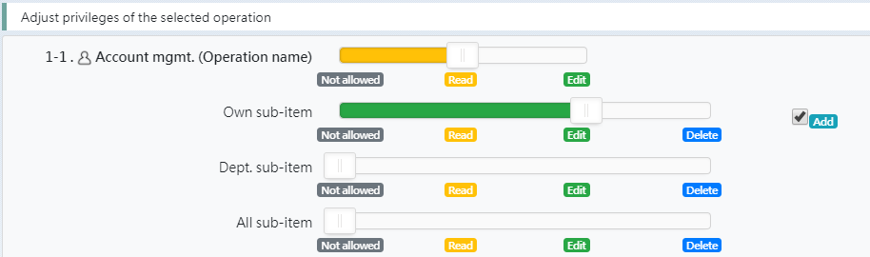

The following is detailed description.



This setting means that all accounts belonging to the role [user] can see the [Account mgmt.] in System Menu. If you change the lever to “Not allowed”, all accounts belonging to the role [user] will not find [Account mgmt.] in System Menu.



This setting means that all accounts belonging to the role [user] can add accounts in the [Account mgmt.] and modify the account data they have added, but they cannot delete accounts they have added.

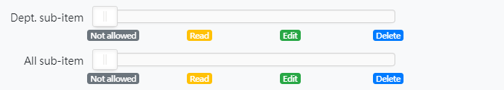

This setting means that all accounts belonging to the role [user] cannot see the accounts that added by others.

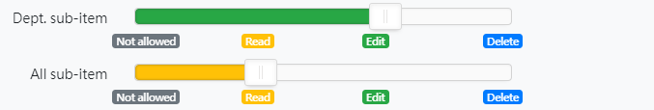

If set [Dept. sub-item] to “Edit” and set [All sub-item] to “Read”, that means all accounts belonging to the role [user] can modify the account added by the same department in [Account mgmt.] and can see the accounts added by others but the Edit button is not available.

The authorization will not take effect until you press the Save button  after changing the authorization settings.

### Usage Scenario: Add role and copy privileges

After finding role list according to the [Usage Scenario: View designated role data]. If you are granted the right to add a role, you can find the Add new button  below the unit subject [Role & Privilege mgmt.].

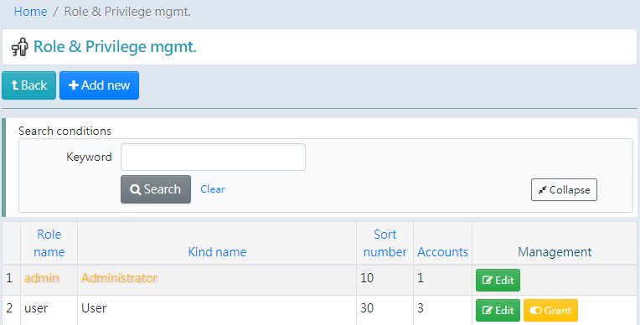

Press the Add new button to open blank form and fill in the role name, kind name and select the source role of the copy privileges (as shown below).

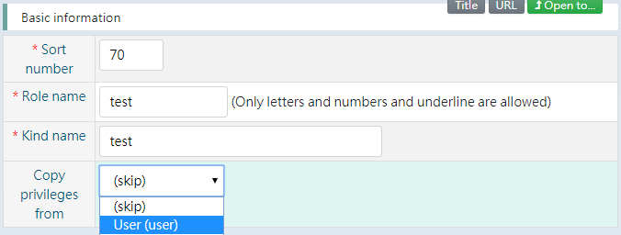

Press the Save button  to complete the data creation.

* Ony letters, numbers, and underline are allowed to fill in field [Role name]. The field [Role name] is not allowed to change after saving.

### Usage Scenario: Delete role

After finding role list according to the [Usage Scenario: View designated role data] (as shown below). If you are granted the right to delete a role and the designated role is not selected by any account, you can find the Delete button  in the field [Management] of data of role list.

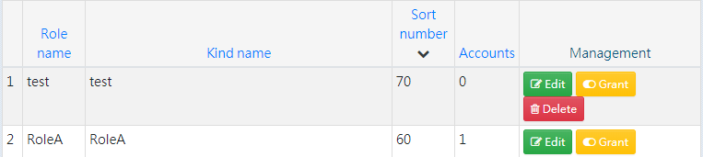

Press the Delete button and a confirmation message will appear (as shown below). Press OK to delete role data.

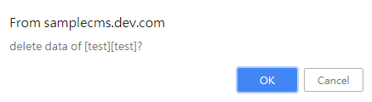

## Department management

### Usage Scenario: View designated department data

After logging in to the system, select [System Management / Department mgmt.] from System Menu.

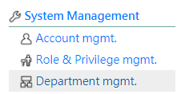

You can see the department list of this system (as shown below). If you are authorized, you can see more departments.

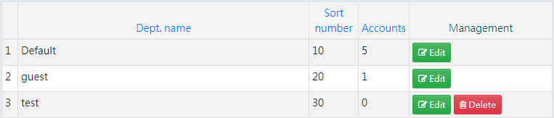

If there are too many departments, you can use search conditions or press on the field name to change data order to help find departments (as shown below).

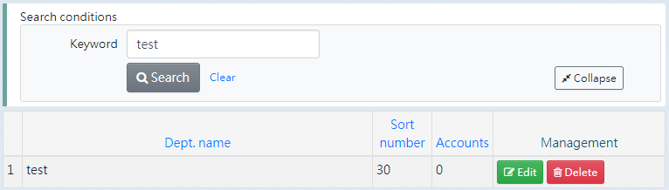

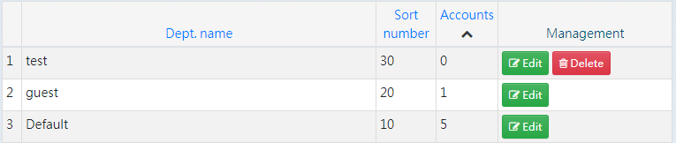

There are some fields or department can be seen in the department list. Press the Edit button to open department data will get more information (as shown below).

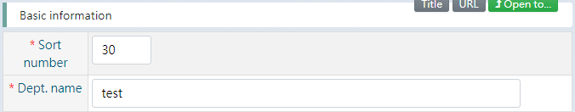

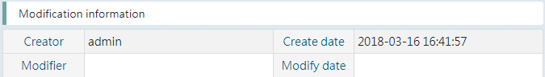

### Usage Scenario: Change name, sort number of department basic information

After finding designated department according to the [View designated department data], press the Edit button  to open department data (as shown below).



Modify the text of fields and press the Save button  to update data.

### Usage Scenario: Add department

After finding deparment list according to the [View designated department data]. If you are granted the right to add a department, you can find the Add new button  below the unit subject [Department mgmt.].

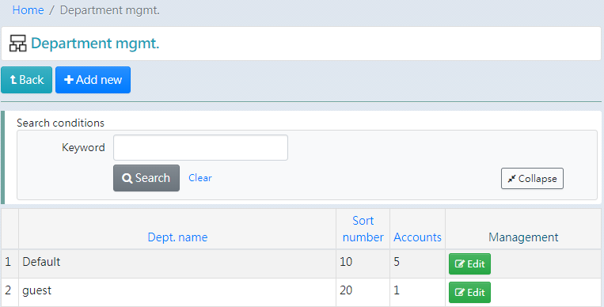

Press the Add new button to open blank form and fill in the data of new department.

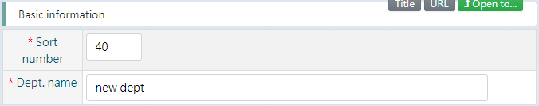

Press the Save button  to complete the data creation.

### Usage Scenario: Delete department

After finding department list according to the [View designated department data] (as shown below). If you are granted the right to delete a department and the designated department is not selected by any account, you can find the Delete button  in the field [Management] of data of department list.

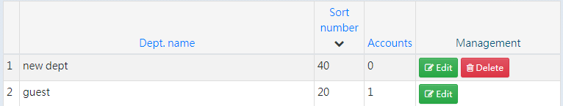

Press the Delete button and a confirmation message will appear (as shown below). Press OK to delete department data.

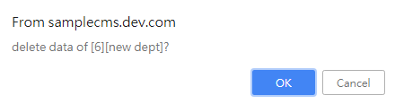

## Operating log

### Usage Scenario: View operating log

After logging in to the system, select [System Management / Operating log] from System Menu.

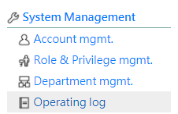

You can see the operating log records of this system (as shown below).

Most users can only see personal records and the records of the owning account. Administrators or other authorized users can see other people’s records.

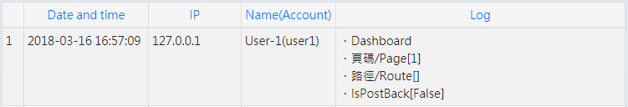

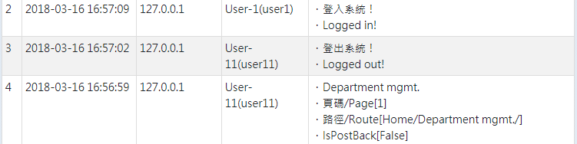

You can use search conditions or press on the field name to change data order to help find records (as shown below).

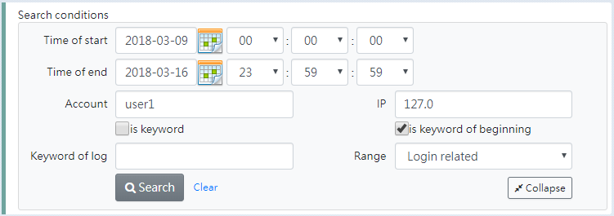

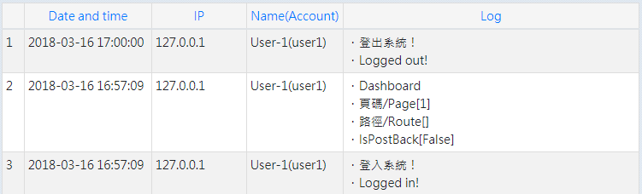

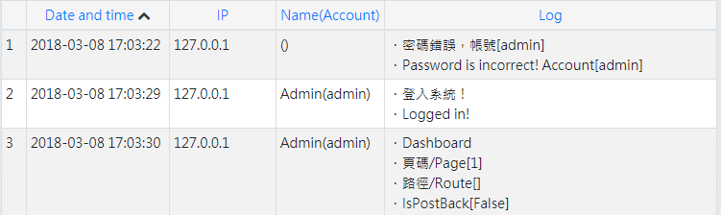

# Site Architecture Management

Site Architecture Management is the most important function of this system. It provides the ability to organize all page hierarchies and manage the presentation, content, and attachments of each page.

In this system, [Site Architecture Management] is used as the home page of front-stage website. The hierarchical structure of web pages is as shown below.

Site Architecture Management / Home page of front-stage website

Sitemap

Search result

Layout type

Custom layout

Wide contents

2-Col. contents

List-Items-Thumb

List-Blocks

文章3

文章2

Articles

文章

文章

Articles

文章3

文章2

Articles

文章

文章

Articles

## Usage Scenario: View designated page data

After logging in to the system, find [Site Architecture Mgmt.] in System Menu. Hovering the mouse cursor in [Site Architecture Mgmt.] will expand the list of sub-pages. Similarly, keeping the cursor at the designated sub-page will continue to list the sub-pages of it. Find the designated page item and press to open it.

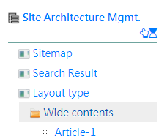

Or perhaps the designated page item has been created as one of the operation of System Menu. For example, [Site Architecture Mgmt. / Layout type / Wide contents] is placed on the [Content Mgmt. / Wide contents] of System Menu, press this one will open the [Site Architecture Mgmt. / Layout type / Wide contents].

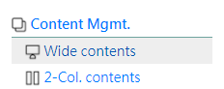

The following picture shows the example of page information. There are some fields of page data can be seen. There are “Validation date”, “Modify information”, “Page type”, “Sub-items”, “Attachments” ,”Pictures”, “Youtube videos”, and “Context preview”. These features will be explained in other usage scenarios.

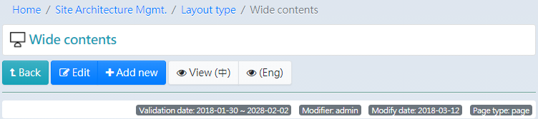

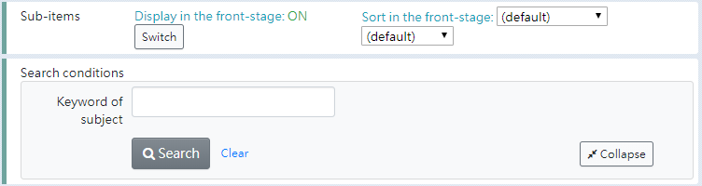

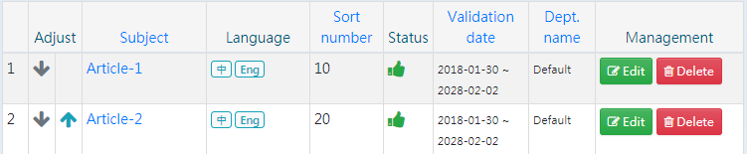

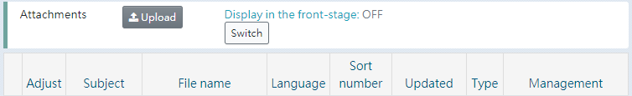





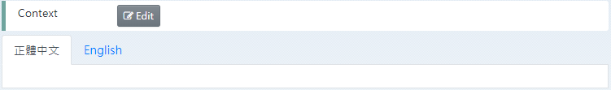

Press the Edit button  below the unit subject to open page data will get more information.

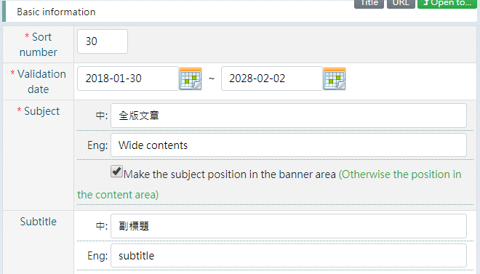

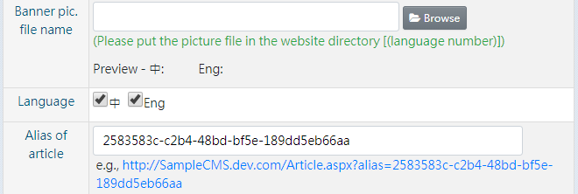

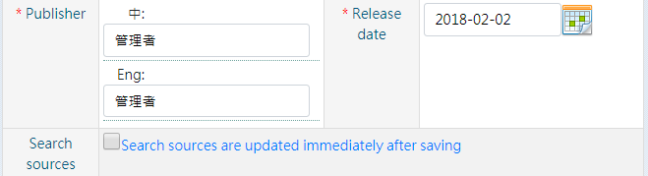

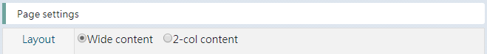

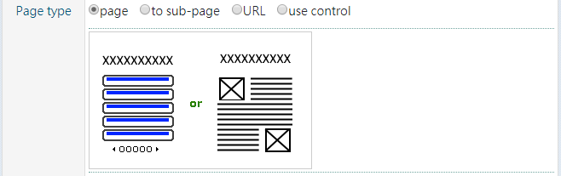

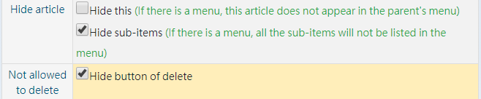

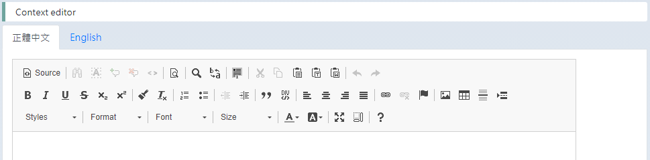

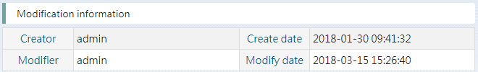

To view the corresponding front-stage page, press the specific language View button  below the unit subject to open front-stage page.

If the designated page status is hidden or not in [Validation date], the view button will be changed to the Preview button . Press the specific language Preview button, system will open the front-stage page in the preview mode, and the notification message “You are using preview mode to view this page” appears in the page content.

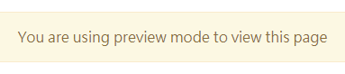

* Based on the principle of security. Each time the URL used to preview the designated page is time-limited, Currently 10 minutes. When the preview URL has been generated for more than 10 minutes and continues to be used to open the web page, it will be transferred to error page.

## Usage Scenario: Add sub-page data at designated page (unit)

After finding the designated page (unit) according to the [Usage Scenario: View designated page data], take [Site Architecture Mgmt. / Layout type / Wide contents] as an example, If you are granted the right to add a page, you can find the Add new button  below the unit subject.

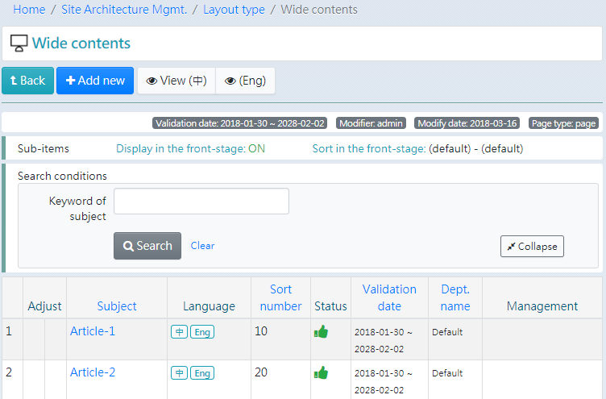

Press the Add new button to open blank form and fill in the data you need. Take the commonly used article field as an example, there are “Validation date”, “Subject”, “Subtitle”, “Banner picture”, “Language switch”, “Publisher”, “Release date”, and “Context”.

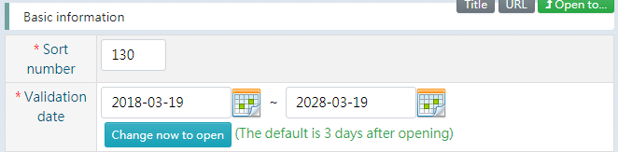

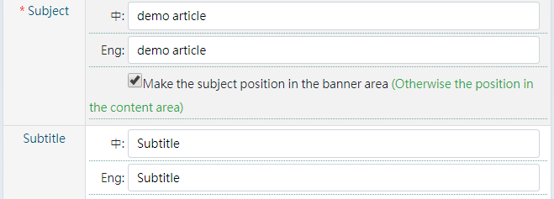

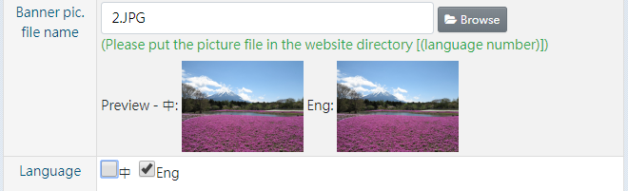

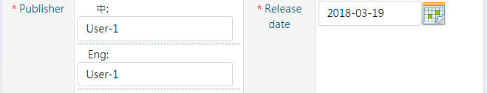

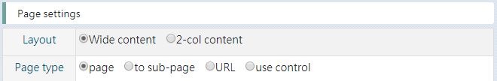

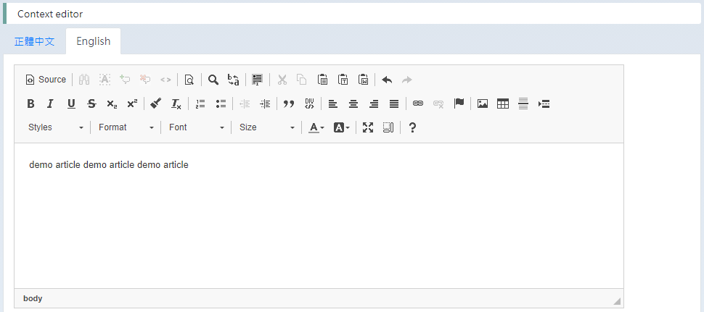

* Validation date: The system default is to change the page to appear at front-stage after 3days, and the start date will be shifted back 3 days. If you would like this page to appear at front-stage immediately, press the Change now to open button  to change the start date to today.

* select Banner picture file: Press the Browse button  to open File Manager (as shown below). If the content is list, please press the Icons button  in the upper right corner to switch to icon mode.

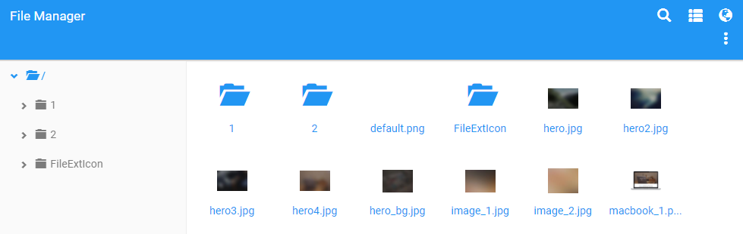

The banner picture needs to use the image file in the folder [language number]. 1 is Chinese, 2 is English. Double click the folder 1  (or press the folder 1 in left side menu ) enter the Chinese picture area (as shown below).

(If you are viewing on a mobile phone, press on the folder 1 for 1 second to call up a menu and press the Open button )

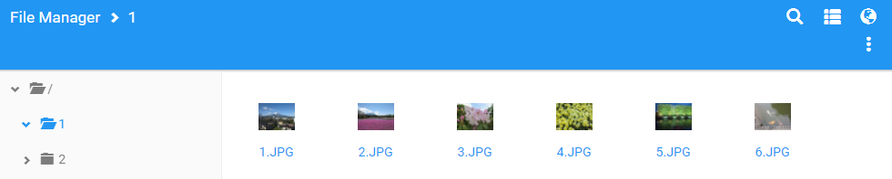

View the detail of the image file. Use the right mouse button on the designated item to call a menu and press the View item button  (as shown below).

(If you are viewing on a mobile phone, press on the designated item for 1 second to call up a menu)

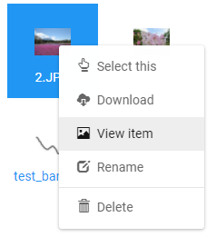 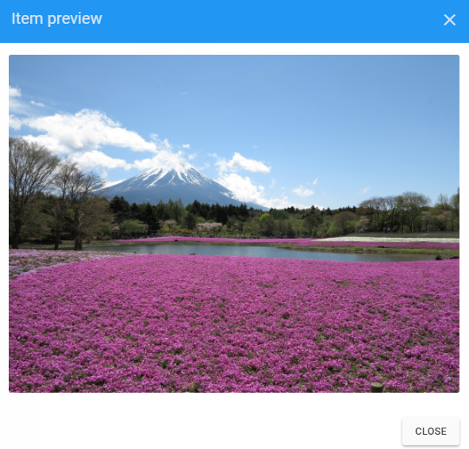

After confirming the image file, please double-click the designated image file to determine the choice. The system will bring the image file name back to the form of Add an article.

(If you are viewing on a mobile phone, press on the designated image file for 1 second to call up a menu and press the Select this button )



* About the fields of Page settings section, in this usage scenario, you only need to use the default value that the system automatically brings.

Press the Save button  to complete the data creation. The newly added page will appear on the last item of the sub-items of the current page (as shown below).



Press the subject link of newly added page item to open page data (as shown below). Confirm that the newly added data and the data presented at the front-stage are correct or not according to the [Usage Scenario: View designated page data]. To continue adding attachments, pictures, and videos, see the following usage scenarios.

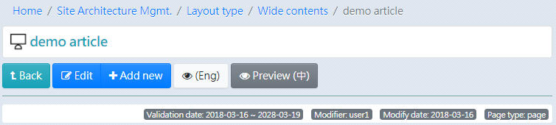

## Usage Scenario: use angular-filemanager to manage files

angular-filemanager is used in this system to select pictures. For example, “select banner picture of page”, “insert picture in context editing”, and “select icon of operation data”.

angular-filemanager provides the functions for managing folders and files.

* When adding a folder or uploading a file, press the More button  in the upper right corner of the screen to expand the menu. Press the feature you need (as shown below).

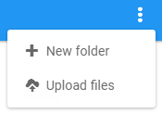

* When changing folder name or file name, or delete folder or file. Please use the right mouse button to call a menu on the designated folder or file and press the feature you need (as shown below).

(If you are viewing on a mobile phone, press on the designated image file for 1 second to call up a menu)

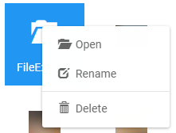 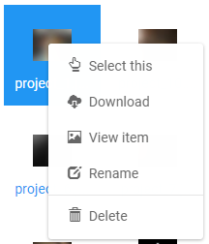

## Usage Scenario: Add attachment of designated page

After finding the designated page according to the [Usage Scenario: View designated page data]. Attachments section and the Upload button  are below the Sub-items section.

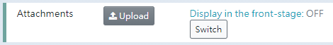

Press the Upload button  to open blank form and fill in subject, check language, and choose file you would like to upload.

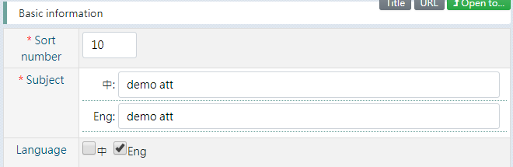

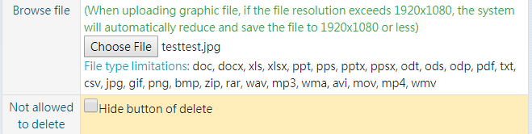

Press the Save button  to complete the data creation and file uploading.

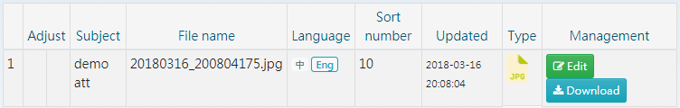

After the attachment is added, it will not appear on the front-stage immediately. If you are sure that you want to display the list of attachments in the front-stage page, press the Switch button  to change the value of “Display in the front-stage” to ON (as shown below).



Press the specific language View button  to open the front-stage page to confirm.

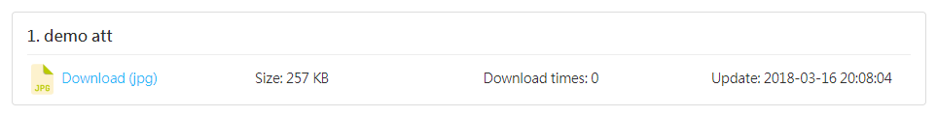

In addition, if there are multiple attachments, Attachment data for the same title will be merged into a group in front-stage page. For example, uploaded items 1 and 2 have the same title in the image below.

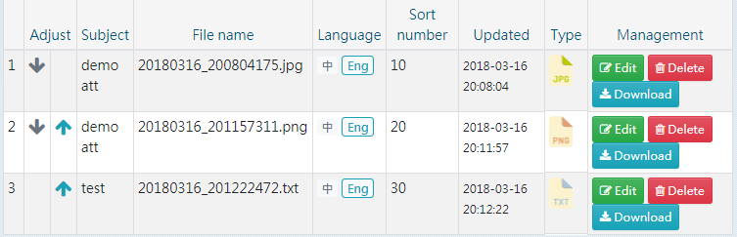

The image below shows the presentation in the front-stage page.

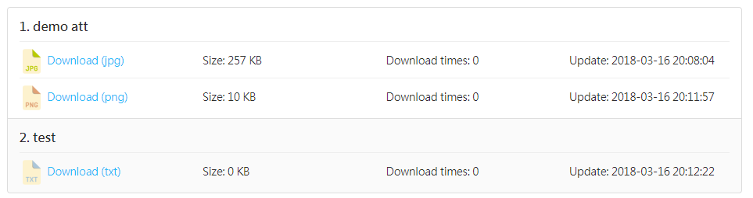

## Usage Scenario: Add picture of designated page

After finding the designated page according to the [Usage Scenario: View designated page data]. Pictures section and the Upload button  are below the Attachments section.



Press the Upload button  to open blank form and fill in subject, check language, and choose file you would like to upload.

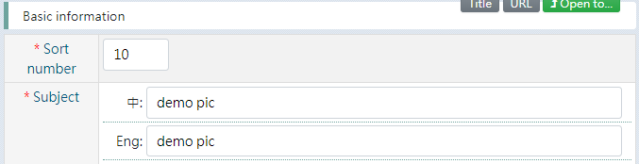

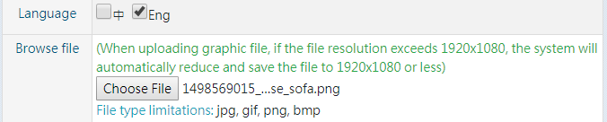

Press the Save button  to complete the data creation and file uploading.

After the picture is added, it will not appear on the front-stage immediately. If you are sure that you want to display the pictures in the front-stage page, press the Switch button  to change the value of “Display in the front-stage” to ON (as shown below).



Press the specific language View button  to open the front-stage page to confirm.

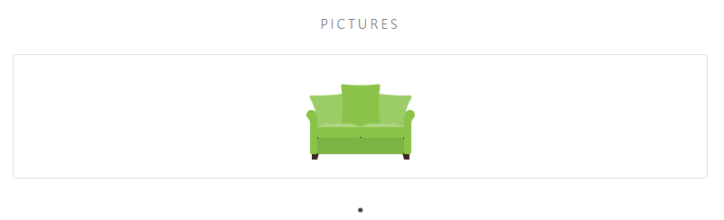

If there are multiple pictures, it shows one picture at a time by carousel (as shown below).

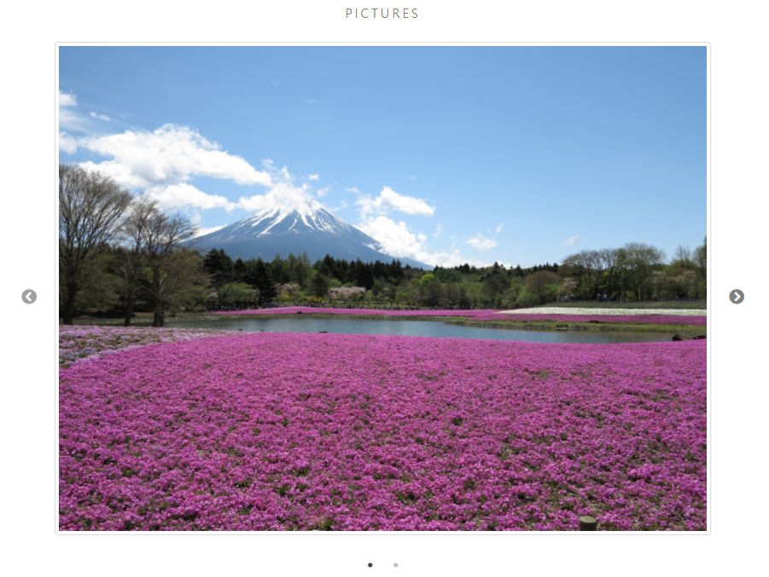

## Usage Scenario: Add picture in context of page

Edit the context of page data. Use cursor to choose the place where you would like to insert the picture in Context editor. (as shown below)

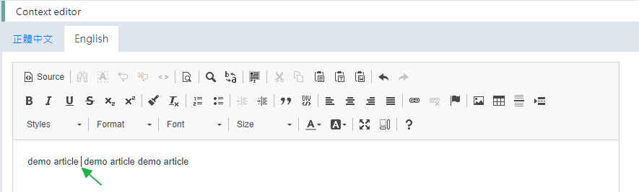

Press the Image button  in editor toolbar to open Image Properties from (as shown below).

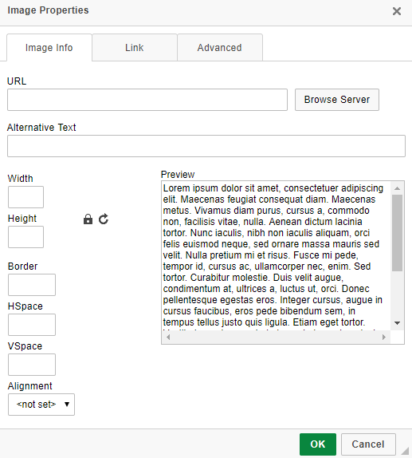

Press the Browse Server button  to open File Manager to choose file (as shown below). Double-click on the designated image file to determine the choice.

(If you are viewing on a mobile phone, press on the designated image file for 1 second to call up a menu and press the Select this buton)

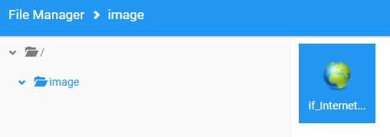

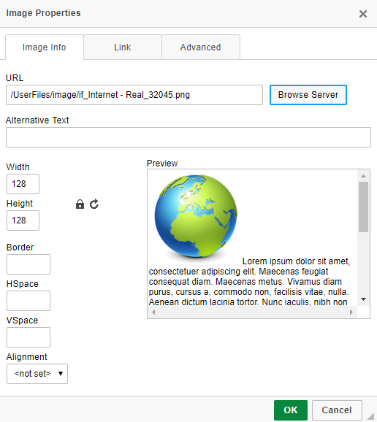

Press the OK button  to insert the image at the position of cursor in context.

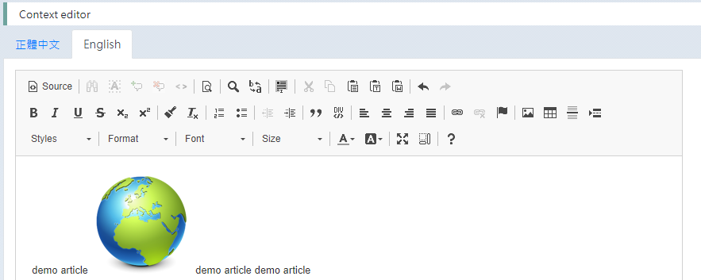

If you need to adjust the image properties, press the image and then press the Image button  in editor toolbar to open Image Properties form. Or use the right mouse button on the designated image to open the menu, and then press the Image button .

If you need advanced way to adjust, press the Source button  to modify the html source code directly.

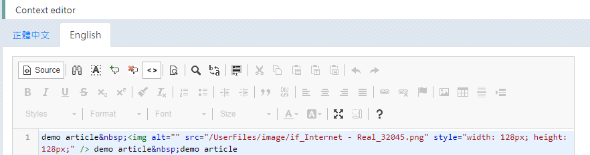

## Usage Scenario: Add Youtube video of designated page

After finding the designated page according to the [Usage Scenario: View designated page data]. Youtube videos section and the Add button  are below the Pictures section.



Press the Add button  to open blank form and fill in subject and check language.

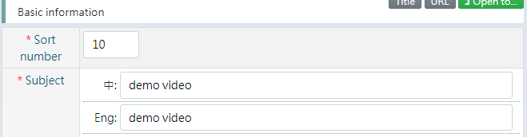

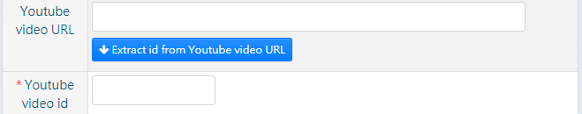

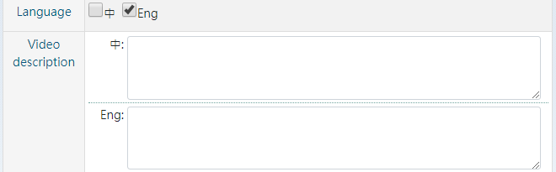

Copy the URL of Youtube video page to the field [Youtube video URL], and then press the Extract id from Youtube video URL button  to get id and fill in description (as shown below).

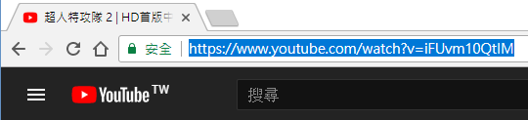

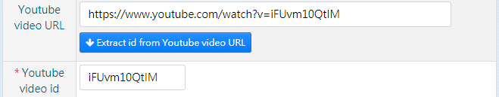

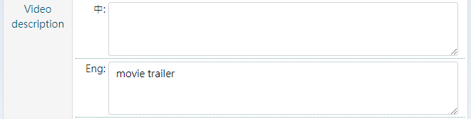

Press the Save button  to complete the data creation.

After the video is added, it will not appear on the front-stage immediately. If you are sure that you want to display the videos in the front-stage page, press the Switch button  to change the value of “Display in the front-stage” to ON (as shown below).



Press the specific language View button  to open the front-stage page to confirm. If there are multiple videos, it shows up to 4 video previews at time by carousel (as shown below).

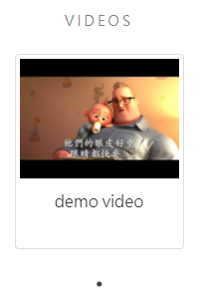 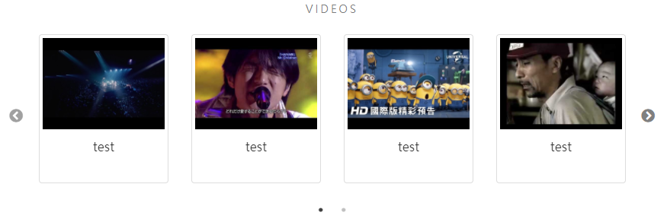

## Usage Scenario: Change layout of page

After finding the designated page according to the [Usage Scenario: View designated page data]. The field [Layout] is in the Page settings section of page data form (as shown below).

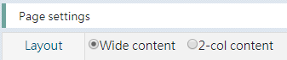

The difference in front-stage page layout performance is as follows.

Wide content /

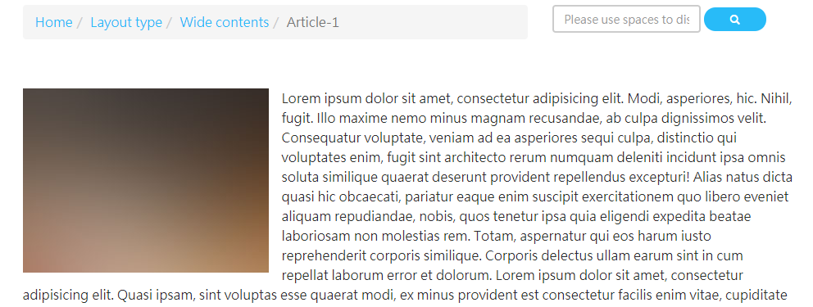

2-Col. content, reserve space for the right menu /

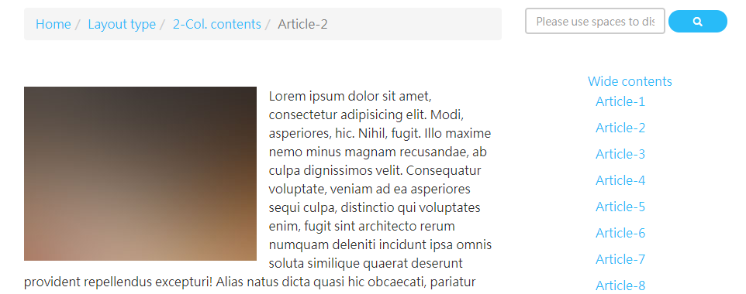

## Usage Scenario: Create a page that will transfer to sub-page automatically

Sometimes a web page node is required as a category name but page context is not required. In order to prevent users from staying on this page, you can make this page redirect to a sub-page automatically. For example, page [About Us] has two sub-pages [Privacy Policy] and [Security Policy], and need to change the page [About Us] to redirect to a sub-page automatically

After finding the designated page according to the [Usage Scenario: View designated page data], or adding a new page. The field [Page type] is in the Page settings section of page data form, Select the value of [Page type] to “to sub-page”.

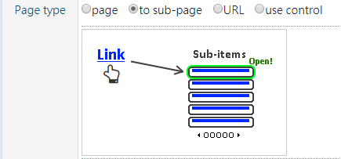

Press the Save button  to update data.

Press the specific language View button  to open the front-stage page to confirm. The action of clicking [About Us] to open the content becomes to open sub-page [Privacy Policy].

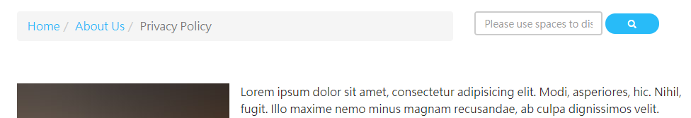

## Usage Scenario: Create a list page

Adding a new page according to the [Usage Scenario: Add sub-page data at designated page (unit)], change the value of field [Page type] of Page settings section to “page” (as shown below).

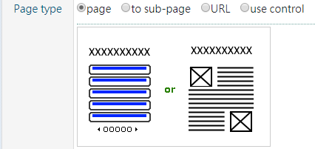

Press the subject link of newly added page to check Sub-items section. Make sure the value of “Display in the front-stage” is ON.



Then, as long as you continue to add sub-pages, the presentation of this page in front-stage is to list all sub-pages as a list. The picture below shows the page [Wide contents] of front-stage, more than 10 sub-pages will be paged.

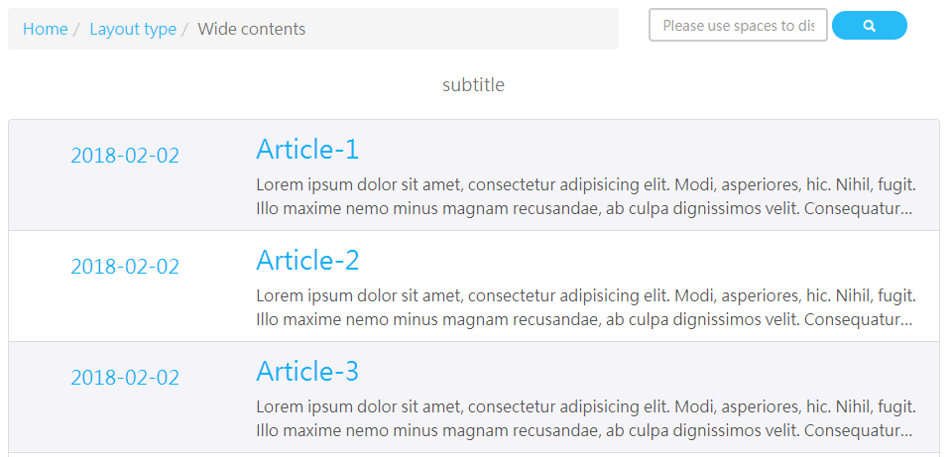



* Since the value “page” of field [Page type] allows the sub-page list to be rendered at the same time with the page context. It is recommended that you do not enter page context when creating a list page.

## Usage Scenario: Make the hyperlink of designated page appear in the unit area

After finding the designated page according to the [Usage Scenario: View designated page data], or adding a new page. In addition, the designated page must be at the first level under [Site Architecture Mgmt.].

There is a field [Appear in the unit are] in Page settings section of page data form, the default value of this field is unchecked (as shown below). Change the value of this field to checked, the subject of the designated page will appear in the unit area in the upper right corner of the front-stage page.



Take the page [Layout type] as an example, the rendering of the unit area in the front-stage page is as follows. If there are sub-pages, the sub-pages will be listed as pop-up menu.



If you do not want to list sub-pages in the unit area, please change the value of field [Hide article / Hide sub-items] in Page settings section to checked.



The following picture shows the presentation of unit area in front-stage page after changing the setting.



## Usage Scenario: Make the hyperlink of designated page appear in the sitemap

After finding the designated page according to the [Usage Scenario: View designated page data], or adding a new page. In addition, the designated page must be at the first level under [Site Architecture Mgmt.].

There is a field [Appear in the sitemap] in Page settings section of page data form, the default value of this field is checked (as shown below).



Take the page [Layout type] as an example, the rendering of the sitemap in the front-stage is as follows. If there are sub-pages, the sub-pages will be listed in an indented list, listing up to 2 levels.

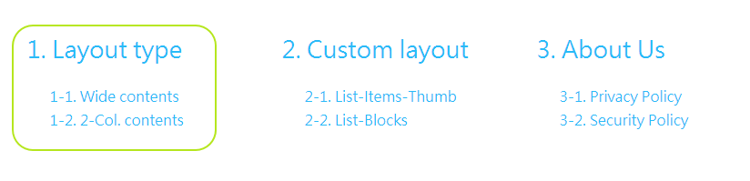

If you do not want to list sub-pages in the sitemap, please change the value of field [Hide article / Hide sub-items] in Page settings section to checked.



The following picture shows the presentation of sitemap in front-stage after changing the setting.

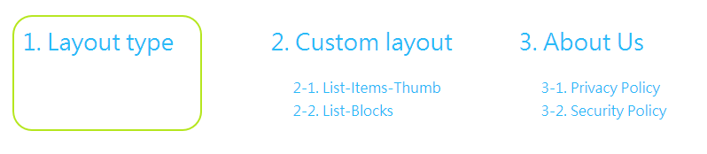

If you do not want to list the designated first level page in the sitemap, please change the value of field [Appear in the sitemap] in Page settings section to unchecked.



Take the page [Layout type] as an example, the rendering of the sitemap in the front-stage is as follows.

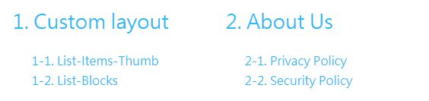

## Usage Scenario: Change the designated page to become a hyperlink to open an external web page

After finding the designated page according to the [Usage Scenario: View designated page data], or adding a new page.

There is a field [Page type] in Page settings section of page data form, change the value of this field to “URL” (as shown below). Take the page [open external page demo] as an example, fill in the URL containing “http://” in the field [URL:] and change the option [Open in new window] to checked.

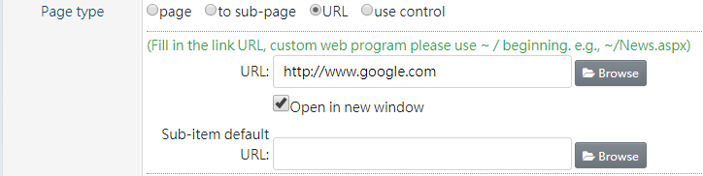

Press the Save button  to update data.

Got to the page [open external page demo], press the specific language View button  to open front-stage page to confirm.

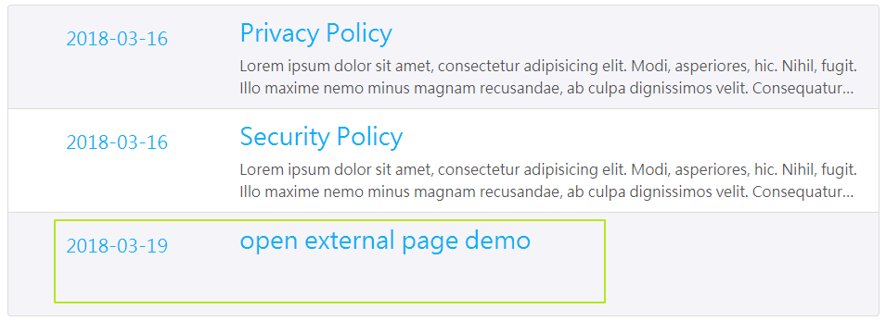

Click the link [open external page demo], it will open a designated external web page in a separate window.

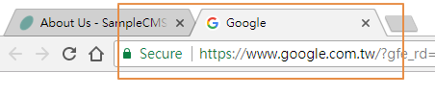

## Usage Scenario: Make designated page using custom web program to render front-stage page

After finding the designated page according to the [Usage Scenario: View designated page data], or adding a new page.

There is a field [Page type] in Page settings section of page data form, change the value of this field to “URL”.

In the current pages, the [Sitemap] and [Search Result] use custom web program to render in front-stage.

Take the [Sitemap] as an example, suppose you want to create this page from the beginning, the field [URL:] is blank (as shown below).

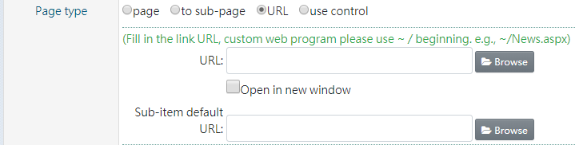

Press the Browse button  behind the field [URL:] to open Custom web programs form (as shown below).

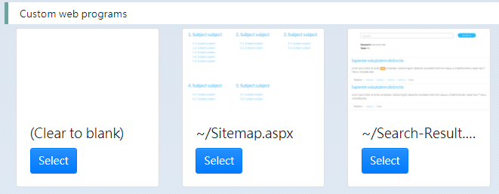

Click on thumbnails to see enlarged previews of front-stage page layout.

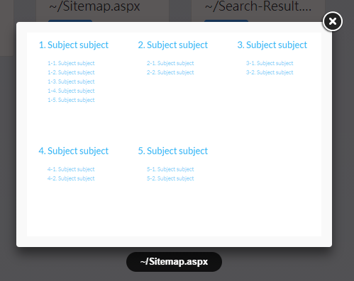

Take the [Sitemap] as an example, press the Select button  of [~/Sitemap.aspx] here. After selecting, the field [URL:] will be brought into “~/Sitemap.aspx”.

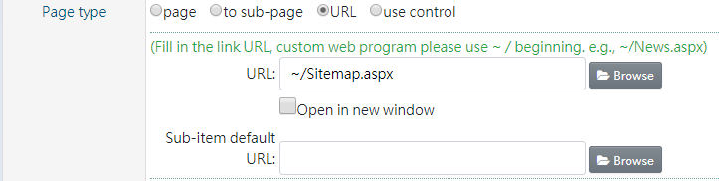

Press the Save button  to update data.

After changing setting, in addition to the [Sitemap] front-stage page changed to use custom web program rendering, the URL of front-stage page also changed to use http://DomainName/Sitemap.aspx to open (as shown below).

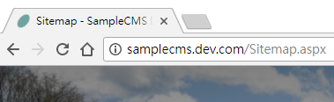

* About the field [Sub-item default URL:], if this field is set, the system will automatically change the value of field [Page type] to “URL” and fill in the value of field [URL:] with the value of field [Sub-item default URL:] of parent-page in the form of adding sub-page.

## Usage Scenario: Make designated page using layout control to render front-stage page

After finding the designated page according to the [Usage Scenario: View designated page data], or adding a new page.

There is a field [Page type] in Page settings section of page data form, change the value of this field to “use control”.

In the current pages, the [List-Items-Thumb] and [List-Blocks] under [Custom layout] use layout control to render in front-stage.

Take the [List-Items-Thumb] as an example, suppose you want to create this page from the beginning, the field [Control:] is blank (as shown below).

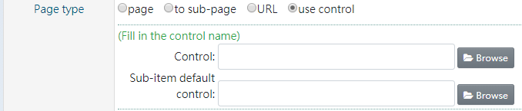

Press the Browse button  behind the field [Control:] to open Layout controls form (as shown below).

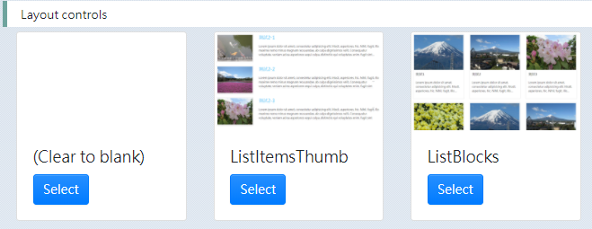

Click on thumbnails to see enlarged previews of front-stage page layout.

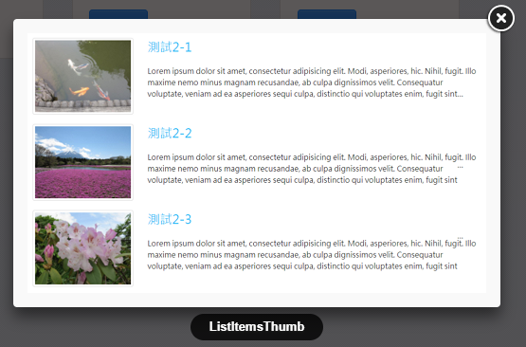

Take the [List-Items-Thumb] as an example, press the Select button  of [ListItemsThumb] here. After selecting, the field [Control:] will be brought into “ListItemsThumb”.

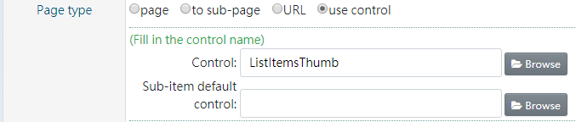

Press the Save button  to update data.

After changing setting, the [List-Items-Thumb] front-stage page changed to use layout control rendering. Unlike the custom web program, the URL of front-stage page still is Article.aspx?artid=xxxxx .

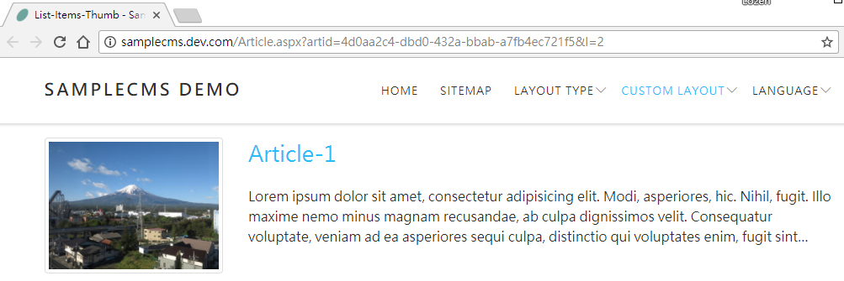

* About the field [Sub-item default control:], if this field is set, the system will automatically change the value of field [Page type] to “use control” and fill in the value of field [Control:] with the value of field [Sub-item default control:] of parent-page in the form of adding sub-page.

## Usage Scenario: Make designated page using easy-to-remember URL alias

After finding the designated page according to the [Usage Scenario: View designated page data], or adding a new page.

There is a field [Alias of article] in Basic information section of page data form, the default value of this field is article id (as shown below).



Take the page [About Us] as an example, fill in “about” to the field and save data. Instead of using the original URL to open [About Us] at front-stage, using Article.aspx?alias=about will also open the same page.

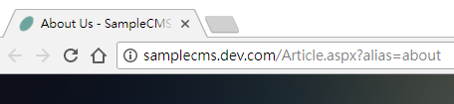

## Usage Scenario: Immediately update search sources

When searching on the front-stage page, search result list content found from search sources. The search sources default to rebuild at midnight each day. Therefore, it may happen that the newly added web page data or updated web page content is not found correctly at the front-stage.

If you would like to update search sources immediately. Change the value of field [Search sources / Search sources are updated immediately after saving] in Basic information section of page data form to checked.



Then, press the Save button  to update data and the system will rebuild the search sources at the same time.

# Operation Management

The [Operation Management] of this system is for administrator use of management functions only. In addition, the guest is specifically allowed to view the list and data.

## Usage Scenario: View designated operation data

After logging in to the system, press the Edit button  upper left corner of the System Menu to enter [Operation Management].

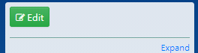

You can see the operation list of this system (as shown below).

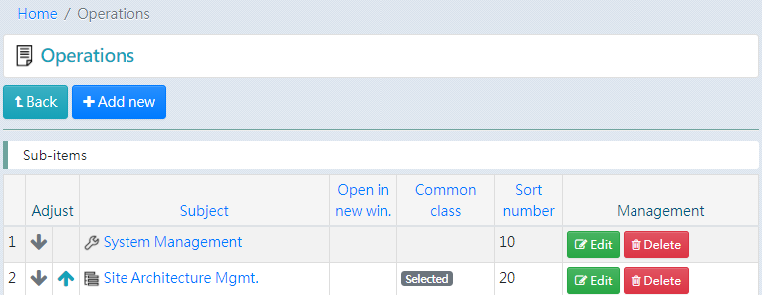

If there are too many operations, you can press on the field name to change data order to help find operation.

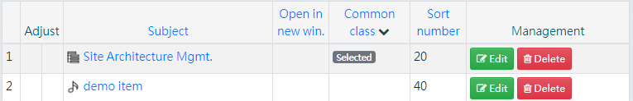

There are some fields of operation data can be seen in the operation list.

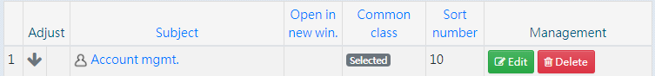

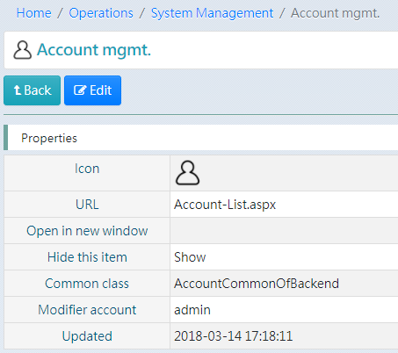

Press the Edit button  to open operation data will get more information (as shown below).

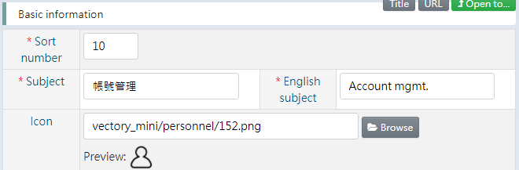

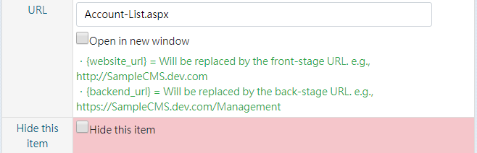

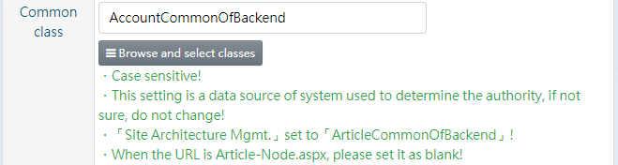

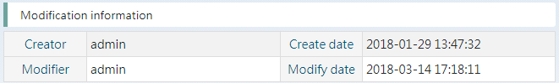

## Usage Scenario: Change subject, icon, to hide or not of operation basic information

After finding the designated operation according to the [Usage Scenario: View designated operation data], press the Edit button  to open operation data (as shown below).





Modify the text of fields or change the value of field [Hide this item], press the Save button to update data.

* When changed to hidden, the operation background will be shown in red in the list, and will not appear in the System Menu.

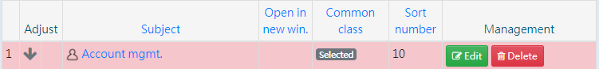

## Usage Scenario: Add operation data as a functional group

Operations can be created up to two levels. Usually the first level is used as a functional group, and the second level is unit entrance. The [Site Architecture Mgmt.] is an exception that requires only one level.

Take the creation of a functional group as an example. you can find the Add new button below the unit subject [Operations].

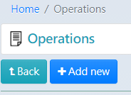

Press the Add new button to open blank form and fill in the subject and pick an icon.

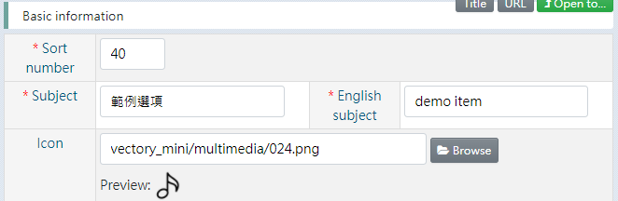

Press the Browse button  behind the text area of icon field to open file manager (as shown below). If the content is list, please press the Icons button  in the upper right corner to switch to icon mode. Double-click the designated image file to determine the choice.

(If you are viewing on a mobile phone, press on the designated image file for 1 second to call up a menu and press the Select this button )

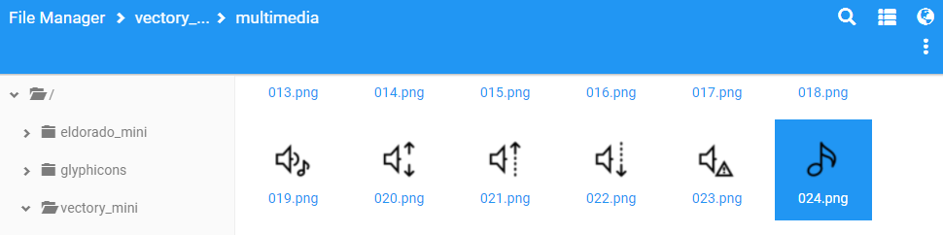

Press the Save button  to update data.

## Usage Scenario: Add operation data that using specific feature

Among the operations, in addition to the first level as a functional group, most of the operations are used as unit entrance. These operations all have fixed values of fields [URL] and [Common class] to be filled in.

Take the [Account mgmt.] as an example, field [URL] needs to be filled in “Account-list.aspx” and field [Common class] needs to be filled in “AccountCommonOfBackend”.

(Press the Browse and select classes button  first to expand the menu)

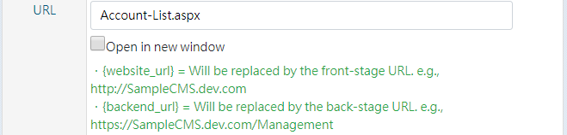

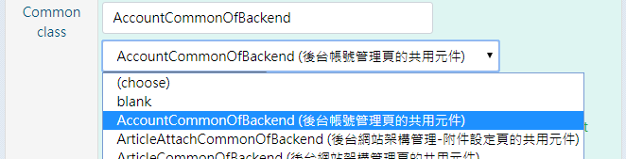

In case you need to re-create the operations, the following are the related settings.

|  |  |  |  |
| --- | --- | --- | --- |
|  | Subject | URL | Common class |
|  | Account mgmt. | Account-List.aspx | AccountCommonOfBackend |
|  | Role & Privilege mgmt. | Role-List.aspx | RoleCommonOfBackend |
|  | Department mgmt. | Department-List.aspx | DepartmentCommonOfBackend |
|  | Operating log | Back-End-Log.aspx | BackEndLogCommonOfBackend |
|  | Site Architecture Mgmt. | Article-Node.aspx | ArticleCommonOfBackend |

## Usage Scenario: Add operation data with embedded web page

When adding a operation, just fill in the field [URL] starting with “http://” and make the option [Open in new window] to unchecked. The web page of designated URL will be embedded in page content of this operation. (* Please make sure that the designated external web page is allowed to be embedded by other web pages.)

Take an embedded Youtube video as an example (as shown below), fill in the URL in field [URL].



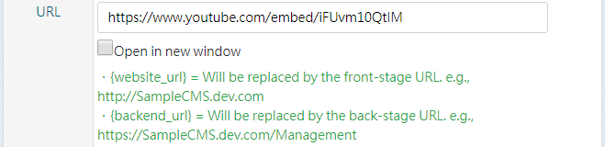

Press the Save button  to complete the data creation.

Find and press this operation in the System Menu.

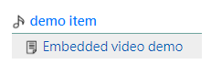

The youtube video is embedded in web page of operation (as shown below).

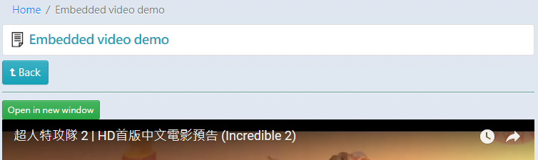

* If the content of the embedded web page is too large, and it is inconvenient to use within a limited range, press the Open in new window button  to open the embedded page to a separate window.

In addition, to embed web pages or resources under this system (e.g., pdf file). The system provides alternate text for you to set the front-stage or back-stage website URL.

．{website_url} = Will be replaced by the front-stage URL. e.g., http://SampleCMS.dev.com

．{backend_url} = Will be replaced by the back-stage URL. e.g., https://SampleCMS.dev.com/Management

For example, embed a pdf file that under back-stage root directory (as shown below). Fill in “{backend_url}/xxxxx.pdf” to field [URL].



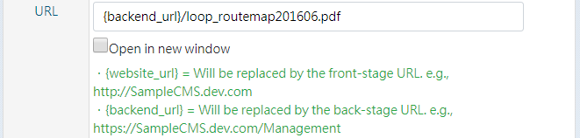

Press the Save button  to complete data creation.

Find and press this operation in the System Menu.

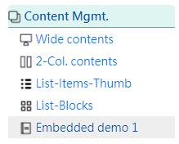

The pdf file is embedded in web page of operation (as shown below).

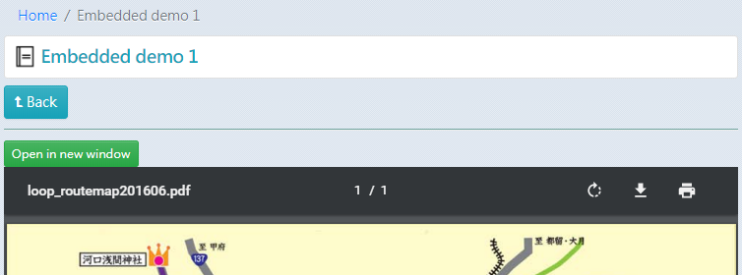

## Usage Scenario: Add operation data with page of [Site Architecture Mgmt.] and set privileges

Although we can adjust the privileges of role for the [Site Architecture Mgmt.] in the button [Grant] of [Role & Privilege mgmt.], if we want to adjust the privileges for the designated page under [Site Architecture Mgmt.], the original function is not enough.

This system allows the designated page URL under [Site Architecture Mgmt.] to be set in the field [URL] of operation data. For example, I hope that the accounts belonging to the RoleA can only add and edit sub-pages in the page [About Us], and it is not allowed to edit the page data of [About Us]. The following are the setting steps.

1. Finding the page [About Us] under [Site Architecture Mgmt.] according to the [Usage Scenario: View designated page data]. Copy the URL of page, e.g., “Article-Node.aspx?artid=xxxxx”.  
   Article-Node.aspx?artid=ac185876-2c6c-483c-81ef-3d0b5ec68764
2. Add an operation under [demo item] of [Operation Management]. Fill in the subject and paste the URL above into the field [URL] and save it (as shown below).



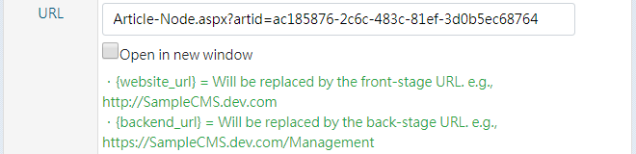

1. After add a role [RoleA] in the [Role & Privilege mgmt.], press the Grant button  of RoleA to open authorization form. Change the value of [demo item] to “Read (Operation)”.

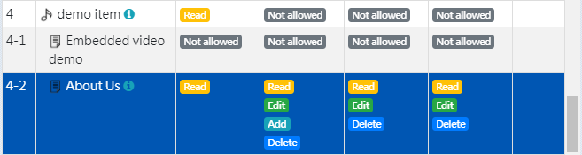

Then change the value of [About Us] to

“Read (Operation)”,

“Add (Own sub-item)”,

“Read, Edit, Delete (All sub-item)”

(As shown below, click on the option at purple 1 and then on the option at purple 2. )

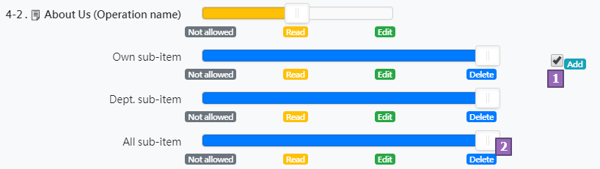

and then save it.

1. Add an account [UserA] in [Account mgmt.] and choose the role [RoleA] (as shown below), and then save it.  
   
2. Log in to the system using account [UserA]. You can only see the [demo item, About Us] in the System Menu.

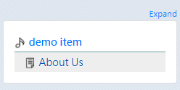

Press the [About Us] to open page data. You can’t use the Edit button of [About Us] to modify data according to the authorization settings. You can only add the sub-pages of it.

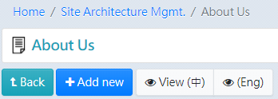

You can edit and delete all sub-pages according to the authorization settings

